Assignment 27.2

**Explain the following in brief by using the below datasets and their uses. Link: order.txt Link: customers.txt**

First, creating tables order1 and then loading the given dataset into the table.

Using select displaying the table data.

Then, creating tables customerdata and then loading the given dataset into the table.

Using select displaying the table data.

After that performing join operations on the created tables.

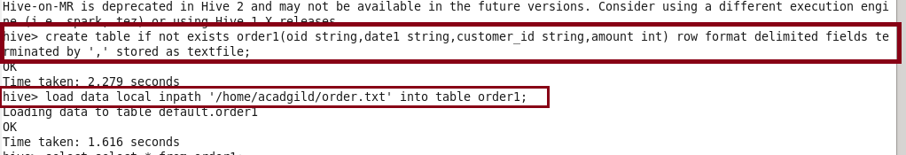

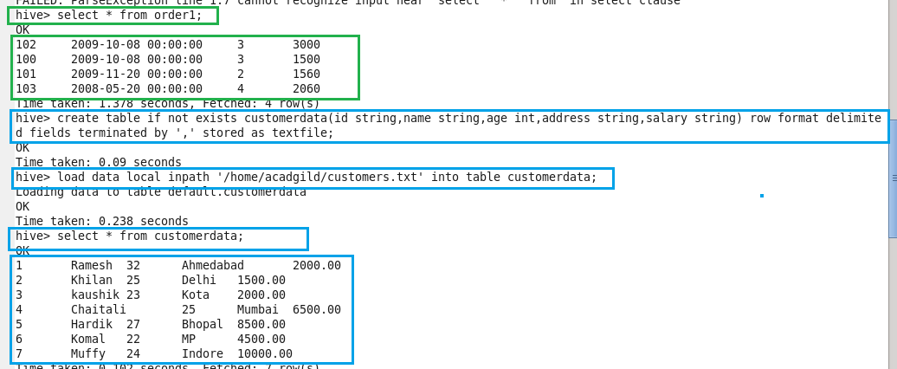

● **JOIN**

JOIN clause is used to combine and retrieve the records from multiple tables. JOIN is same as OUTER JOIN in SQL. A JOIN condition is to be raised using the primary keys and foreign keys of the tables.

Here, joining ‘order1’ and ‘customerdata’ tables using JOIN and ‘select’ is used to display the output.

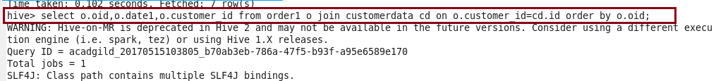

**Output :**

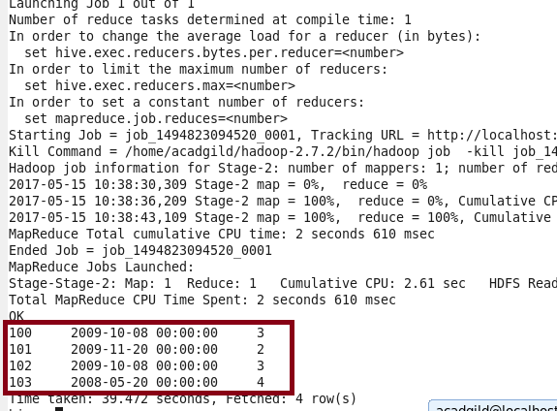

● **Left Outer Join**

A LEFT JOIN returns all the values from the left table, plus the matched values from the right table, or NULL in case of no matching JOIN predicate.

Below is the query using left outer join.

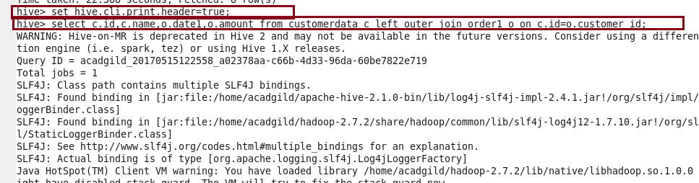

**Output :**

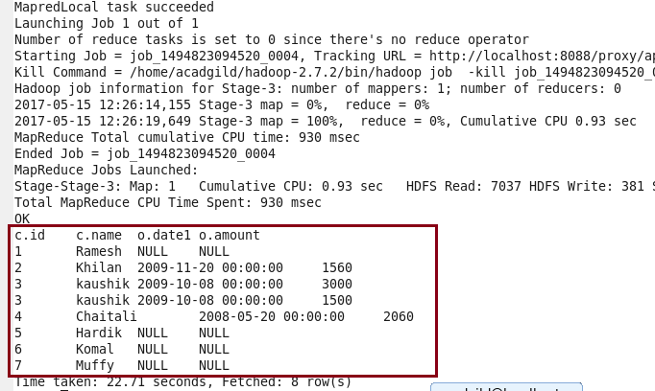

**● Right Outer Join**

A RIGHT JOIN returns all the values from the right table, plus the matched values from the left table, or NULL in case of no matching join predicate.

Below is the query using right outer join.

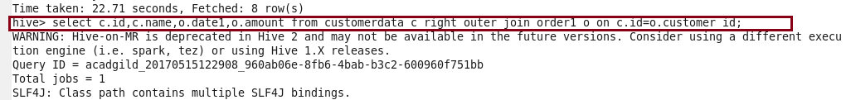

**Output :**

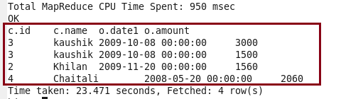

**● Full Outer Join**

The HiveQL FULL OUTER JOIN combines the records of both the left and the right outer tables that fulfil the JOIN condition. The joined table contains either all the records from both the tables, or fills in NULL values for missing matches on either side.

Below is the query using full outer join with output.

